Homework AWS

Task1 Create and attach EBS volume to an EC2 instance

Task1.1 Name existing EBS volumes

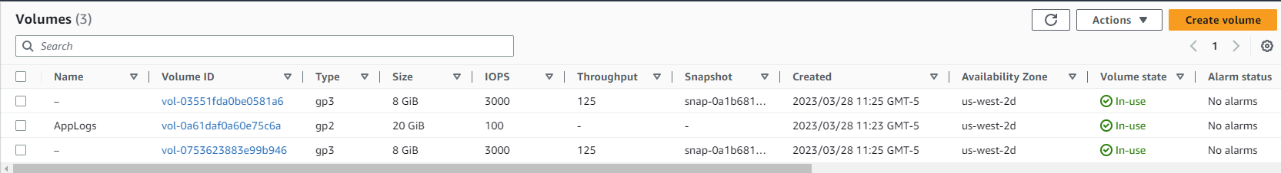

Task1.2 Create EBS volume

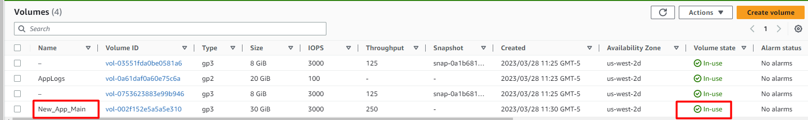

Task2 Create and configure a filesystem on an attached EBS volume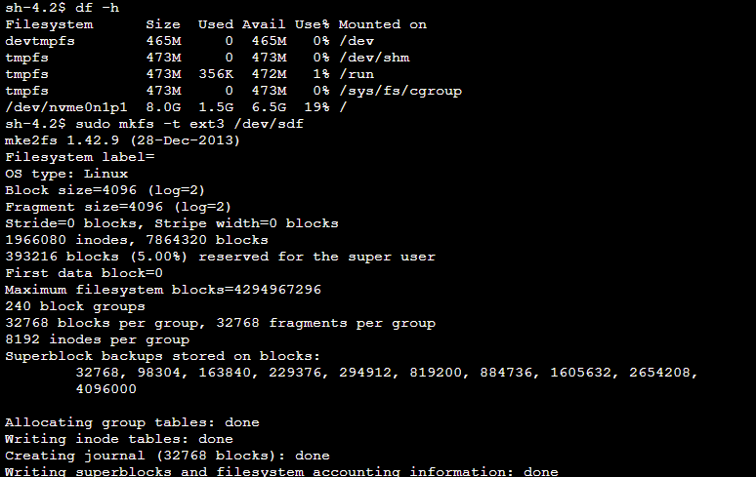

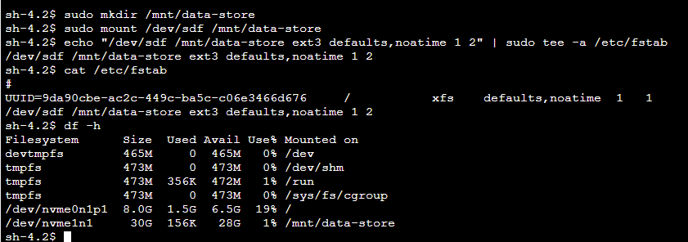

Task3: Modify the EBS volume size and expand the file system on the volume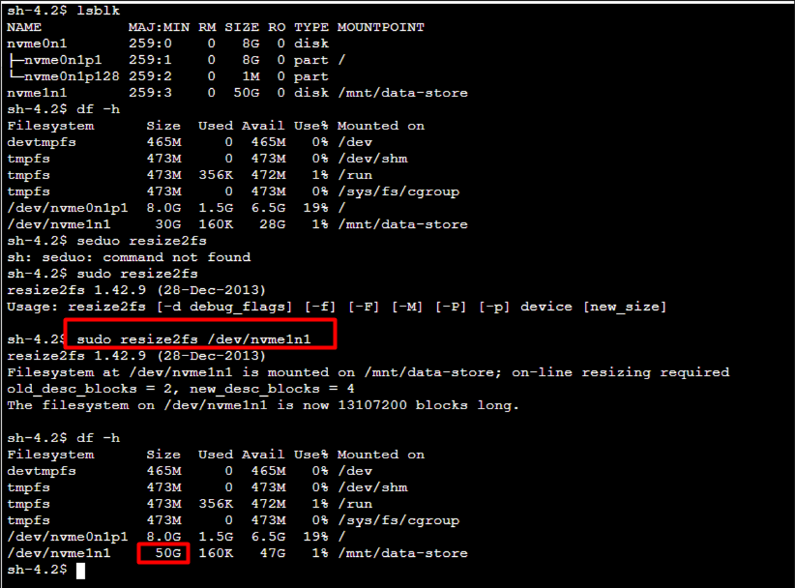

Task4 Modify the EBS volume type and provisioned performance for an existing app.



Task6 Restore an EBS volume from an existing snapshot

